Artificial Intelligence & Machine Learning Course Project Report

Team Members:
Ch.Thrilochan – 1602-23-737-187
K. Vibhas Reddy – 1602-23-737-189

Problem Statement:
Create an intelligent system that predicts the next word in a sentence using a Recurrent Neural Network (RNN). The system should accept user input text, process it, and suggest the most probable next word(s) based on trained language models
Accept partial text input from the user.
Preprocess the input (tokenization, lowercasing, padding, etc.).
Use an RNN (e.g., LSTM / GRU) model trained on a text corpus.
Predict the most probable next word (or top N suggestions).
Display the prediction(s) to the user with option to continue typing.
Algorithm
1. Text Input & Preprocessing Input: A sentence fragment typed by the user. Steps: Tokenize the text into words. Convert words into integer indices using a vocabulary (Tokenizer). Pad/truncate sequences to a fixed length for the model.
2. Model Training (RNN-based Language Model) Use a dataset (e.g., Wikipedia corpus, movie subtitles, or custom dataset). Train an RNN / LSTM / GRU model to learn word sequences. Objective: Minimize categorical cross-entropy loss for next-word prediction. 3. Next Word Prediction Pass the pre-processed user input through the trained model. Output the probability distribution over the vocabulary. Select the top predicted word(s) using Top K Sampling (multiple suggestions).
4. Output Generation Display the predicted word to the user. Optionally allow autocomplete (append word to sentence). Enable iterative continuation of text with repeated predictions

Dataset:
Raw Data (From a Novel of Sherlock Holmes):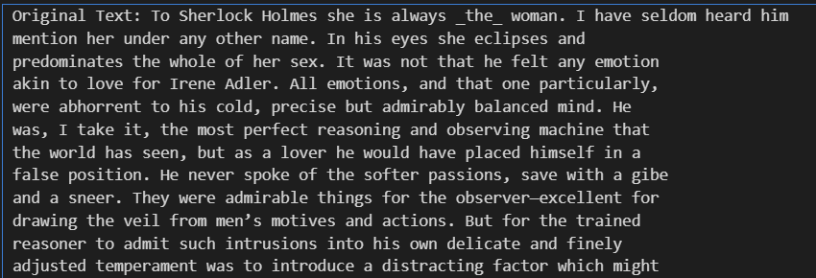
Create training data
---Applying data cleaning and performing string operations to create a dataset of clean data
The data is made into tokens and sequences are generated with a word length of 3.
Sequences:
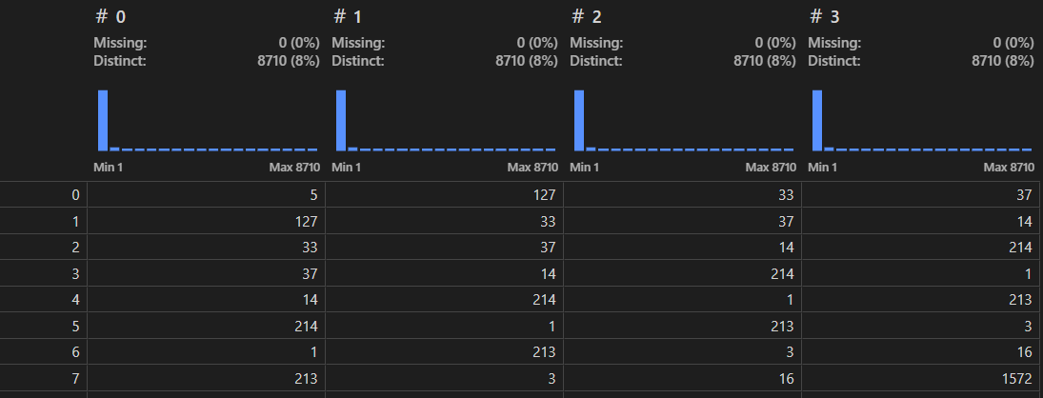
Prepare the data into input sequences and corresponding target words for training the RNN model.
Final dataset Size:
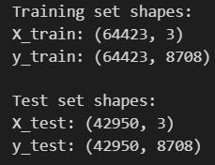
Build the rnn model
Subtask:
Design and build a Recurrent Neural Network model suitable for sequence prediction.
from tensorflow.keras.models import Sequential
from tensorflow.keras.layers import Embedding, LSTM, Dense
# Instantiate a Sequential model
model = Sequential()
# Add an Embedding layer
embedding_dim = 100
model.add(Embedding(input_dim=total_words, output_dim=embedding_dim, input_length=sequence_length))
# Add an LSTM layer
model.add(LSTM(units=150))
# Add a Dense output layer
model.add(Dense(units=total_words, activation='softmax'))
# Print the model summary
model.summary()

Compile and train the model
Subtask:
Compile the model with an appropriate loss function and optimizer, and train it using the prepared training data.
model.compile(optimizer='adam', loss='categorical_crossentropy', metrics=['accuracy'])
# Train the model using training data and validate on test data
history = model.fit(
X_train, y_train,
epochs=100,
validation_data=(X_test, y_test),
verbose=1
)
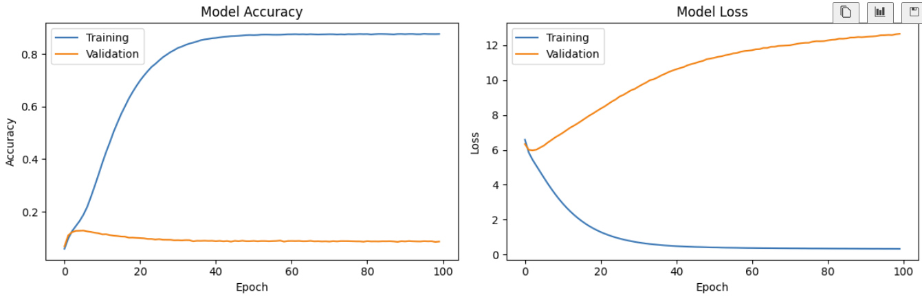

Load Saved Model
Subtask:
Demonstrate how to load and use the saved model and tokenizer.
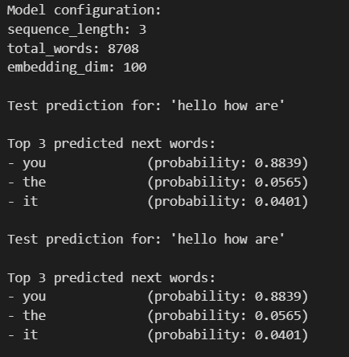

Final Application:
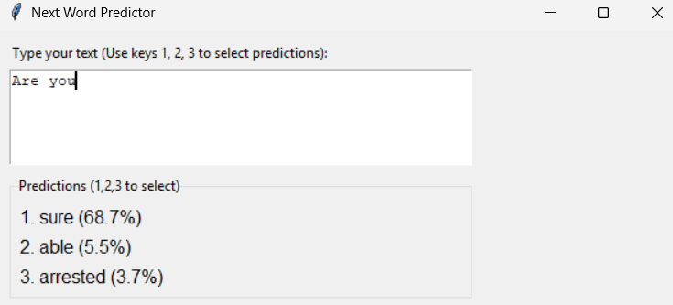
After pressing key ‘1’:
